**Git Exercise**

Date:29/12/2020

1. **Create one repository in git, Clone it in your system, push directory and file structure in git.**

Command to clone the repository:

Git clone <https://github.com/SmitPanchal1999/gitExercise.git>

Change directory to this gitExercise folder

Then I created new directory named “newDir” and “file1.txt” inside it

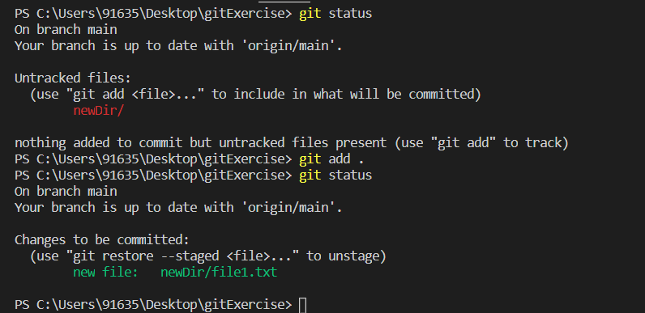

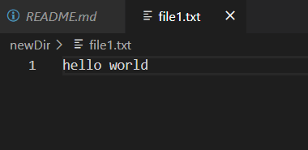

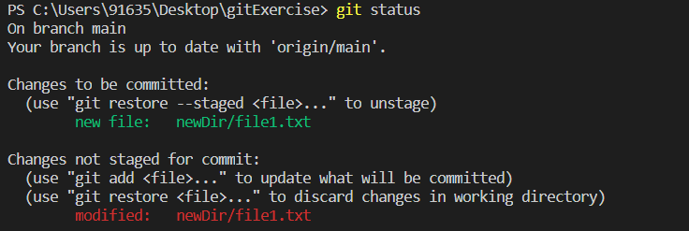

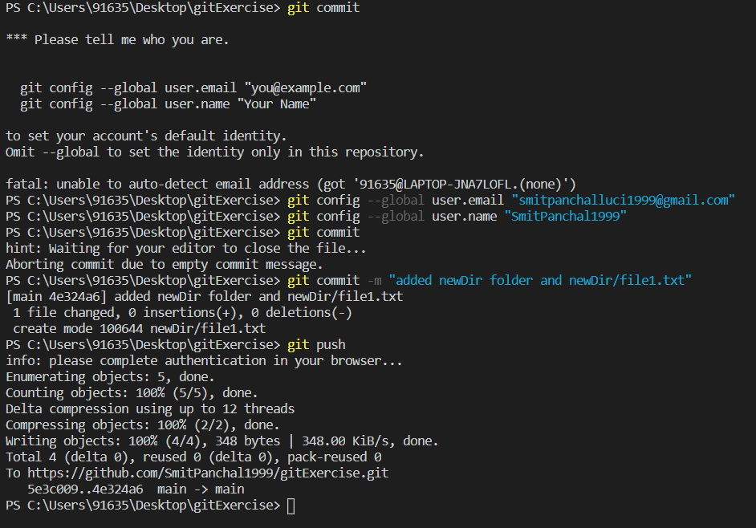

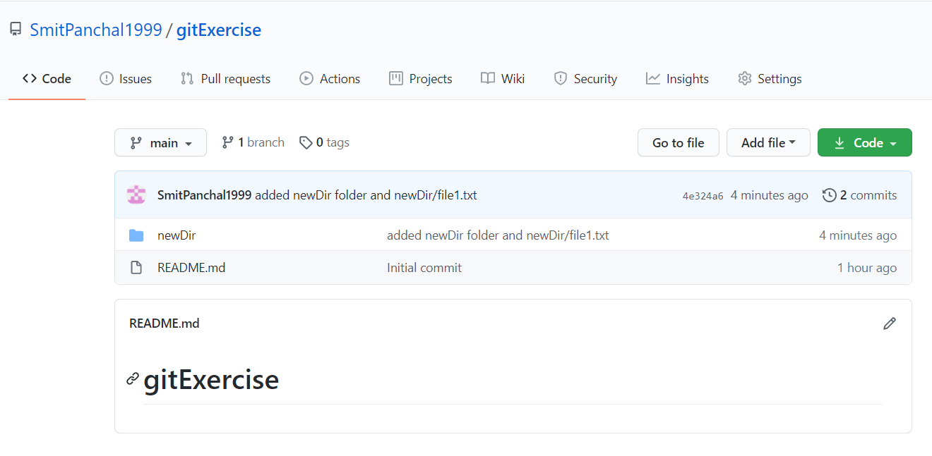

**2.** **Create ‘dev’ branch from master and push some contents (directory with two files) inside this ‘dev’ branch.**

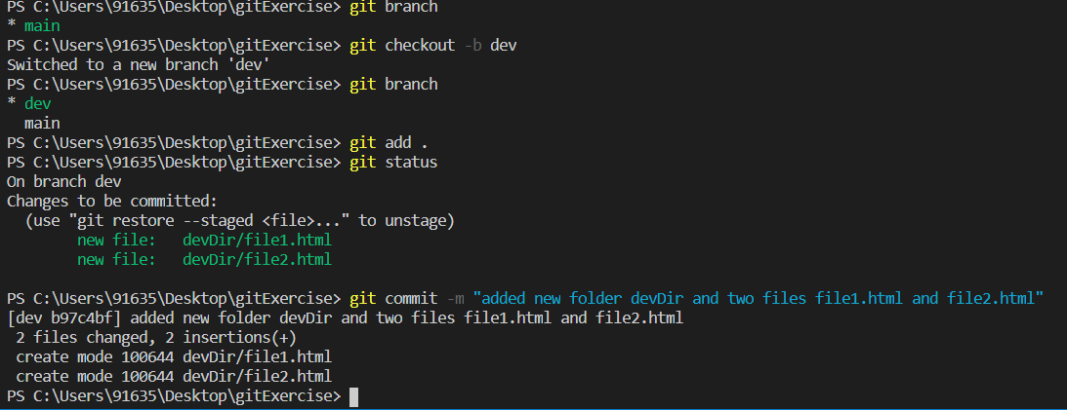

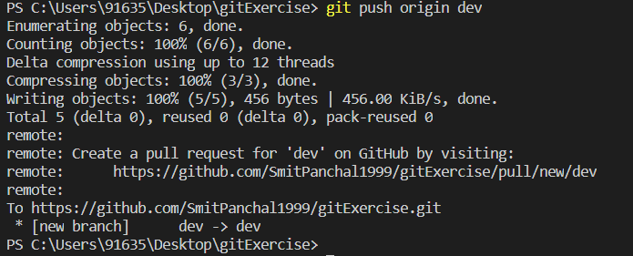

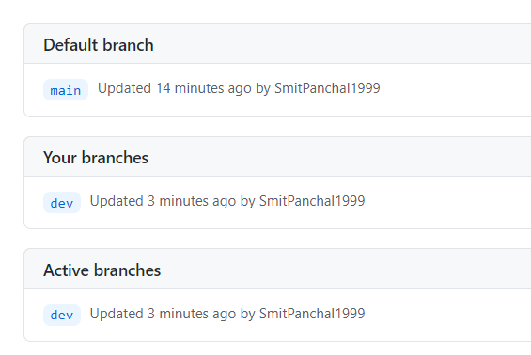

**3.** **Create ‘branch1' branch from ‘dev’ branch, create one file in ‘branch1’, as well as create ‘branch2’ branch and add one file for this branch too.**

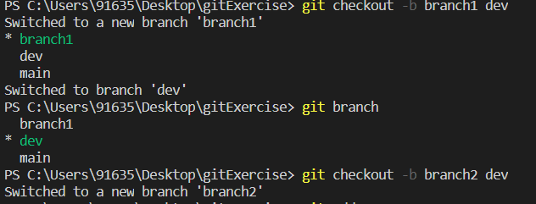

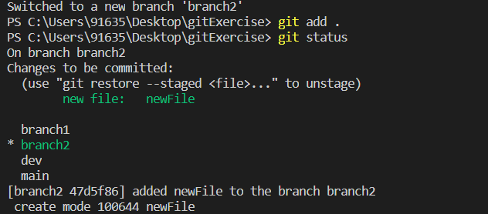

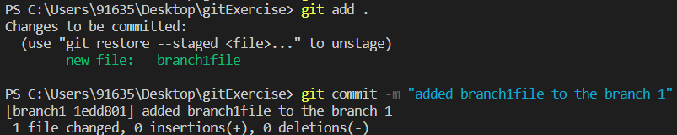

**4. Change some contents in existing file inside ‘branch1’ branch, and do same thing for ‘branch2’**

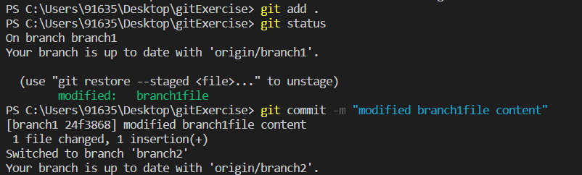

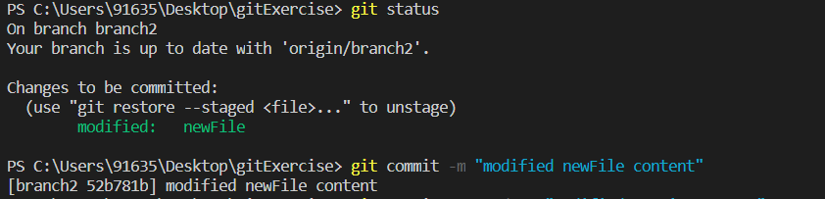

**5. Commit those changes and after committing, change the commit message.**

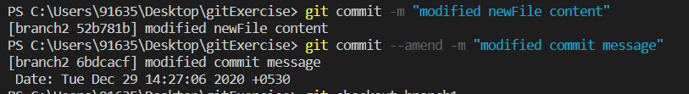

ss5-2.png

**6. After changing commit message you have to push your new changes on git.**

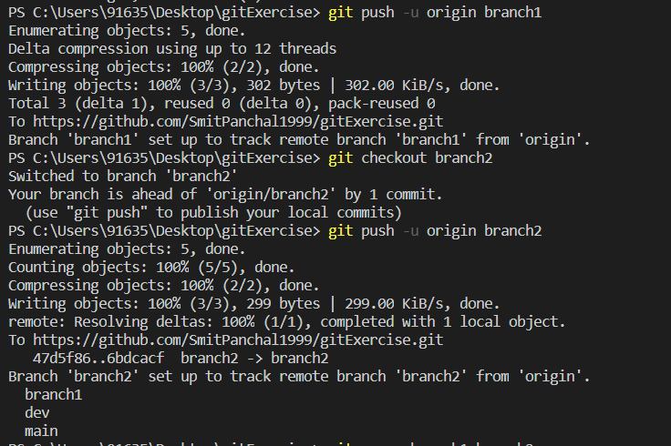

**7.** **Merge ‘branch1’ and ‘branch2’ in dev branch.**

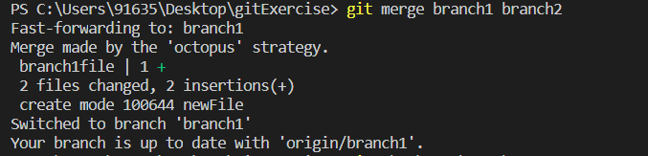

**8.** **Follow the steps:**

**(a). Make a few changes in ‘branch1’ contents**

**(b). Without ‘adding and committing those changes' (branch1), make some changes in branch2 contents (stash your branch1  changes and then apply some changes in branch2)**

**(c). Add and commit your branch2 changes and then come back to branch1 and get back your stash changes.**

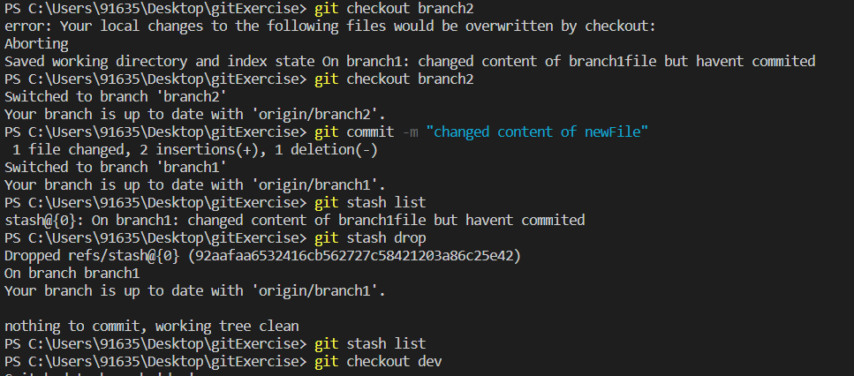

**9.** **Follow the steps:**

**(a). Create two branches from dev, i.e ‘feature1’ & ‘feature2’.**

**(b). Add some content in ‘feature1’ as well as add some content in ‘feature2’**

**(c). Push ‘feature1’ on git**

**(d). Take pull of ‘feature1’ in ‘feature2’**

**(e). Merge ‘feature1’ into ‘dev’ branch**

**(f). Take pull of ‘dev’ branch**

**(g). Push your ‘feature2’ on git**

**(h). Rebase ‘feature2’ with ‘dev’ branch and then merge ‘feature2’ in ‘dev’.**

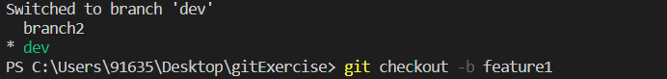

ss9-2.png

